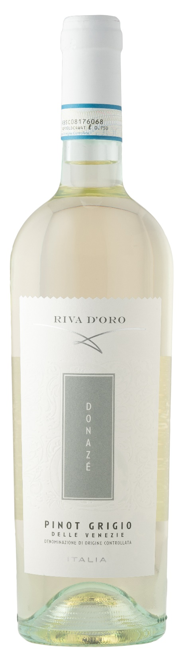
PINOT GRIGIO DOC – DONAZÈ

Grape: Pinot Grigio 100%
Alc. Vol.%: 12
Vintage: 2025
Residual sugar g/l: 4,3
Total acidity g/l: 5,3
Region: Veneto
Production zone: Vineyards in the Venezie Area
Capacity: 750ml, 1500ml

CHARACTERISTICS

Vinification: After the separation of grape-stalk, slow cold fermentation to avoid colour extraction. Then fermentation with selected yeast at a controlled temperature of 16-18°C
Aging: In steel tanks until bottling
Yield per ha: 18000kg
Colour: Straw yellow with greenish sparkles
Bouquet: Elegant and fruity
Flavour: Fresh, smooth and harmonious

SERVING SUGGESTIONS

Best enjoyed with fish dishes, seafood and light starters.
Serving temperature 8 °C
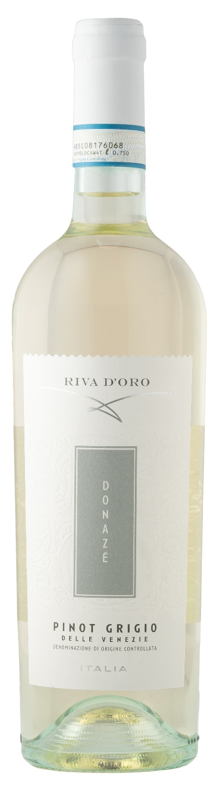
TECHNICAL INFORMATION / PALLETIZING

Size 750ml:
Article Nr. V09008A
GTIN-13 bottle 8017868002697
GTIN-13 carton 8017868004301
Closure Cork
Bottles / carton 6 bottles
Pallet size 80x120cm
Cartons/layer 21
Cartons/pallet 105
Kg/carton 7,8
Kg/pallet 840

Size 1500ml:
Article Nr. V09006B
GTIN-13 bottle 8017868002505
GTIN-13 carton 8017868004677
Closure Screwcap
Bottles / carton 6 bottles
Pallet size 80x120cm
Cartons/layer 14
Cartons/pallet 56
Kg/carton 13,5
Kg/pallet 780

Contains sulphites
GMO Free
Revisione 01. 14.05.2026

